**Prusa Conversion Guide, v0.1**

**Parts to Print**

**Settings: 50% infill, 0.16 mm Creality, 0.15 mm Mini+, 0.15 mm Ultimaker**

Replistruder4_Core.stl – 16:30 / 12:27 / 9:15

Mount_v2 v3.stl – 1:40 / 1:47 / 2:00

2x Replistruder4_CoreSupport_Modified v2.stl – 1:35 / 1:10 / 1:21

Top_Plate_shifterbolts_v2 v2.stl – 0:44 / 0:36 / 0:34

Bottom_Plate_shiftedbolts_v2 v0.stl – 1:00 / 0:56 / 0:44

Version2_NutSide v5.stl – 2:37 / 1:33 / 1:33

Version2_ScrewSide v5 – 2:30 / 1:33 / 1:32

Mini+_allparts_nocore.gcode – 8:44

UM2_Replistruder4_Core – 9:13

**Firmware Modification:**

Download: Prusa-Firmware-Buddy-master

Modify: ./include/marlin/Configuration_MINI_adv.h

Change line 988 to:

#define Z_MIN_POS -80

Change lines 493 and 494:

#define PREVENT_COLD_EXTRUSION

#define EXTRUDE_MINTEMP 0

Run:

python3 ./utils/build.py --generate-bbf

Note that you will have permission errors if you copy files compiled on one computer to run them on another

Now copy:

/build/products/mini_release_boot.bbf

To a USB drive

This should be read automatically (you don't need to hit any buttons) - there will be a warning about how the key for the firmware is invalid (hit ignore).

**Converting Your Prusa Mini+ to a Liquid/Gel FrankenPrinter**

**Part 1 – Gutting your Beloved Printer**

**You’ll need:**

Pliers

2.5 mm Allen / Hex Wrench

Small flathead screwdriver

**Steps**

1. **Unload any filament already loaded in the printer, then switch off and wait for everything to cool down.**
2. **Unscrew the large brass bolt from the extruder mount and remove the plastic tube that usually carries the filament.**

1. **Open up the electronics enclosure and remove plugs 1-5, leaving the black/blue/red/green extruder stepper motor plugged in.**

1. **While you’re here – it’s time for the scary part of the operation. You need to physically break a connection on the motherboard to be able to install custom firmware.** Take a small, flathead screwdriver and break the part of the logic board shown in the photo below. Apply a reasonable amount of force to the thinnest bit of the board – you should end up with something that looks like this:

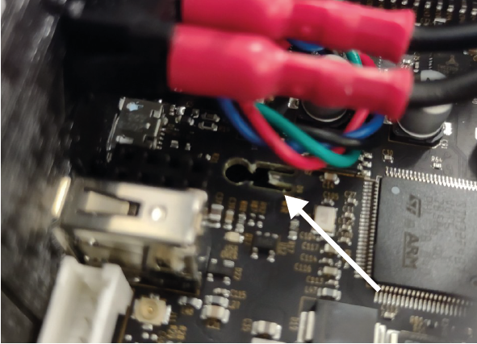

Before doing this, you may want to consult an emotional support website – either a more practical one:

https://help.prusa3d.com/article/flashing-custom-firmware-mini_14

Or simply some pictures of puppies.

1. **Cut the 3 cable ties attached to the extruder stepper mount and remove the wires from the protective sheath, and gently remove the protective sheath.**

1. **Place the cable from the stepper motor back in the protective sheath and replace the motherboard cover and the screws that hold it in place.** You should have something that looks like this:

1. **Now it’s time to remove the hot-end. Remove the screws shown by the white below (it is almost certainly possible to achieve this while removing *fewer* screws).**

1. Finally, (1.) pull the fan out – this might take a bit of force and (2.) remove the final screw attaching the hot end.

1. You should be left with something that looks like the photo below – well done! You’re ready to assemble and mount your new printhead!

**Part 2 – Assembling Your Forklistruder_Mod Printhead**